Goodie Bag
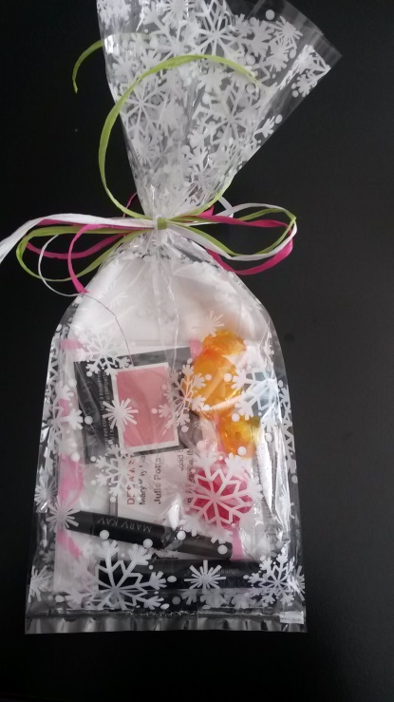
In a pretty fun bag you will want to put all her Party Supplies like:
Washcloth
Mini Mascara or mascara wand
Lip color sample
Fragrance sample or mini hand cream
Your business card
Eye colors and/or Eye Applicator
Candy

Face Bag
In a Mary Kay shopping bag, the small one, you will need the other party supplies:
Profile Card
Sales Ticket
Beauty Book with your info on it
Recruiting page
Hostess Flyer
Pen
Mirror with clear insert

